- Network Devices

Q.1 Draw and label a simple home network diagram showing a router, switch, and three devices (like a laptop, smartphone, and smart TV), indicating how each device connects to the network?
Answer

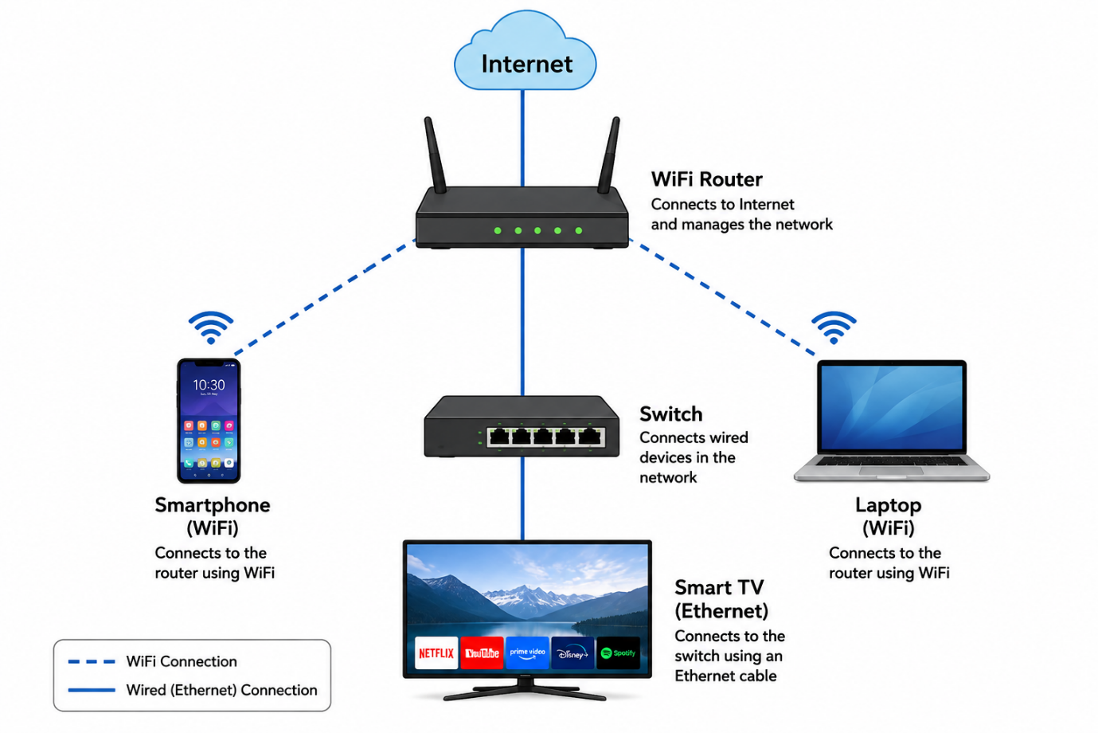

Q.2 Create a comparison table listing at least four network devices (router, switch, hub, access point) and describe one real-world use case for each, referencing apps or services you use daily (e.g., WiFi for streaming on YouTube, LAN gaming, etc.)?
Answer

Network Device | Main Function | Reak-World Use
- Router | Connects different networks and provides internet acess. | Used at home to connect devices to the internet for YouTube, Instagram, or browsing.
- Switch | Connects multiple wired devices in the same network. | Used to connect gaming PCs, smart TVs, and computers for LAN gaming.
- Hub | Sends data to all connected devices. | Can be used in a small basic network to connect multiple computers.
- Acess Point | Provides wireless access to a wired network. | Used to provide WiFi in classrooms, cafés, or offices for phones and laptops.

Q.3 Write a short scenario where you explain how data travels from your phone to the internet when you order food on Zomato, mentioning the role of each network device involved (router, switch, access point)?

Answer
- Zomato Food Order Scenario

- When I order food using Zomato on my smartphone, my phone first connects to the Access Point or WiFi router using WiFi.
- The access point sends the data to the router. The router connects my home network to the internet and sends my Zomato request to the correct server.
- If a switch is present in the network, it helps connect wired devices such as computers, smart TVs, or other network devices to the router.
- The Zomato server receives my order request and sends the response back through the internet to my router. The router then sends the data through WiFi to my phone.
- So, the main path is:
- Phone → Access Point → Router → Internet → Zomato Server

Q.4 Given this situation: you have a WiFi router, but your gaming PC only has an Ethernet port and is far from the router. Suggest two different network devices you could use to connect your PC to the internet and explain how each would work in this setup.<br><br><em><strong>Hint:</strong> Think about devices like switches, powerline adapters, or WiFi extenders.</em>?
Answer
- Connecting a Gaming PC Far from the Router
My gaming PC has only an Ethernet port and is far from the WiFi router. I can use the following two devices:
1. Powerline Adapter
- A powerline adapter uses the electrical wiring of the house to carry network data.
- One adapter is connected to the router using an Ethernet cable and plugged into a wall socket. The second adapter is plugged into a wall socket near the gaming PC and connected to the PC using another Ethernet cable.
- This provides a wired connection without running a very long Ethernet cable through the house.
2. WiFi Extender with Ethernet Port
- A WiFi extender receives the wireless signal from the router and extends it to another area.
- I can place the extender near the gaming PC. The extender connects wirelessly to the router, and I can connect the gaming PC to the extender using an Ethernet cable.
- This allows the PC to access the internet even though it does not have built-in WiFi.

- Conclusion:
A powerline adapter can provide a more stable wired connection, while a WiFi extender with an Ethernet port is easier to set up when the router is far away.

